Diagnostic Essay for EN110

Hello, and welcome to Rhetoric I (EN110). In order for me to get an idea of where the students in this class stand as writers, I’m going to ask you to watch a video clip and respond to the speaker’s argument about why schools are not making changes to promote student success. Explain how this relates to your experience as a student and more specifically, as a writer. Please re-watch the clip for reference, here is the link. It can also be found in Blackboard.

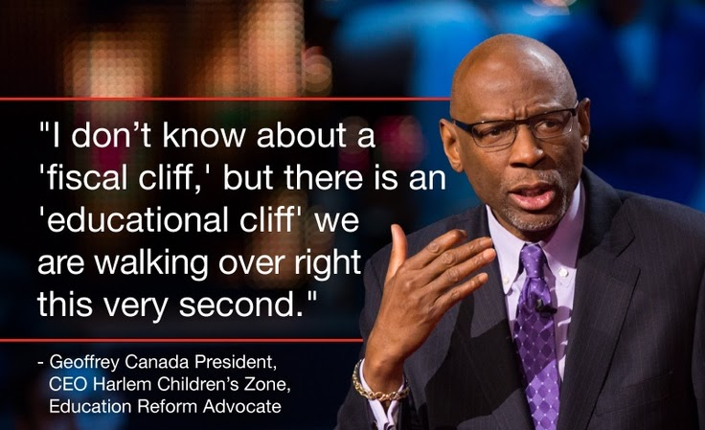

https://www.ted.com/talks/geoffrey_canada_our_failing_schools_enough_is_enough

Learning Objectives: You should be able to address all questions posed below and format the paper in MLA 8th Edition Style with In-Text Citations and a Works Cited Page (1 book, 1 website, and 1 article from the College’s databases).

Why it should matter to you. *The ability to respond completely to assigned tasks and apply the proper formatting with be essential to finding success in future classes and as a professional*
What You Need to Address in Your Response
(We don’t have a page count, so be thorough)

Intro: What is the current state of educational practices according to Geoffrey Canada? How does it compare with your personal experience? What impact had this had on your education and development? Thesis: To what extent are Canada’s representative of your education and how can you overcome these limitations.

Paragraph (para.) 1: What do you think are strengths or assets of the existing educational model? Good intentions? How have you benefitted?

Para. 2: What are the weaknesses or concerns about being able to convey your message through writing as a result of your educational experiences in the described systems? How might these weaknesses hold you back as a student, especially as a writer?

Para. 3: Explain what role engaging your creativity to becoming a better writer will play in achieving your ultimate academic/professional/social long-term goals.

Conclusion: Wrap it all up for me!

Works Cited: Use MLA 8th edition (not a citation generator!!!) to cite at least 1 book, 1 website, and 1 article from our database—make an appointment with me if you need help with this.

**Post in Blackboard (Bb) by creating a thread and copying and pasting your essay in the first discussion board. Comment on two of your classmates responses with a short paragraph of constructive criticism (5-8 sentences).**

***Bring me a hard copy to class, I will return comments the following week.***

